**PRITHWI SECONDARY BOARDING SCHOOL**

Basundhara Kathmandu contact:-01-5904816

**Final Term Examination**

**Grade: Nursery**

**Subject: English**

**Time :**

**Name :**

_________________________________________________________________________________

**Q N.1 Circle the matching small letter in each row.(7)**

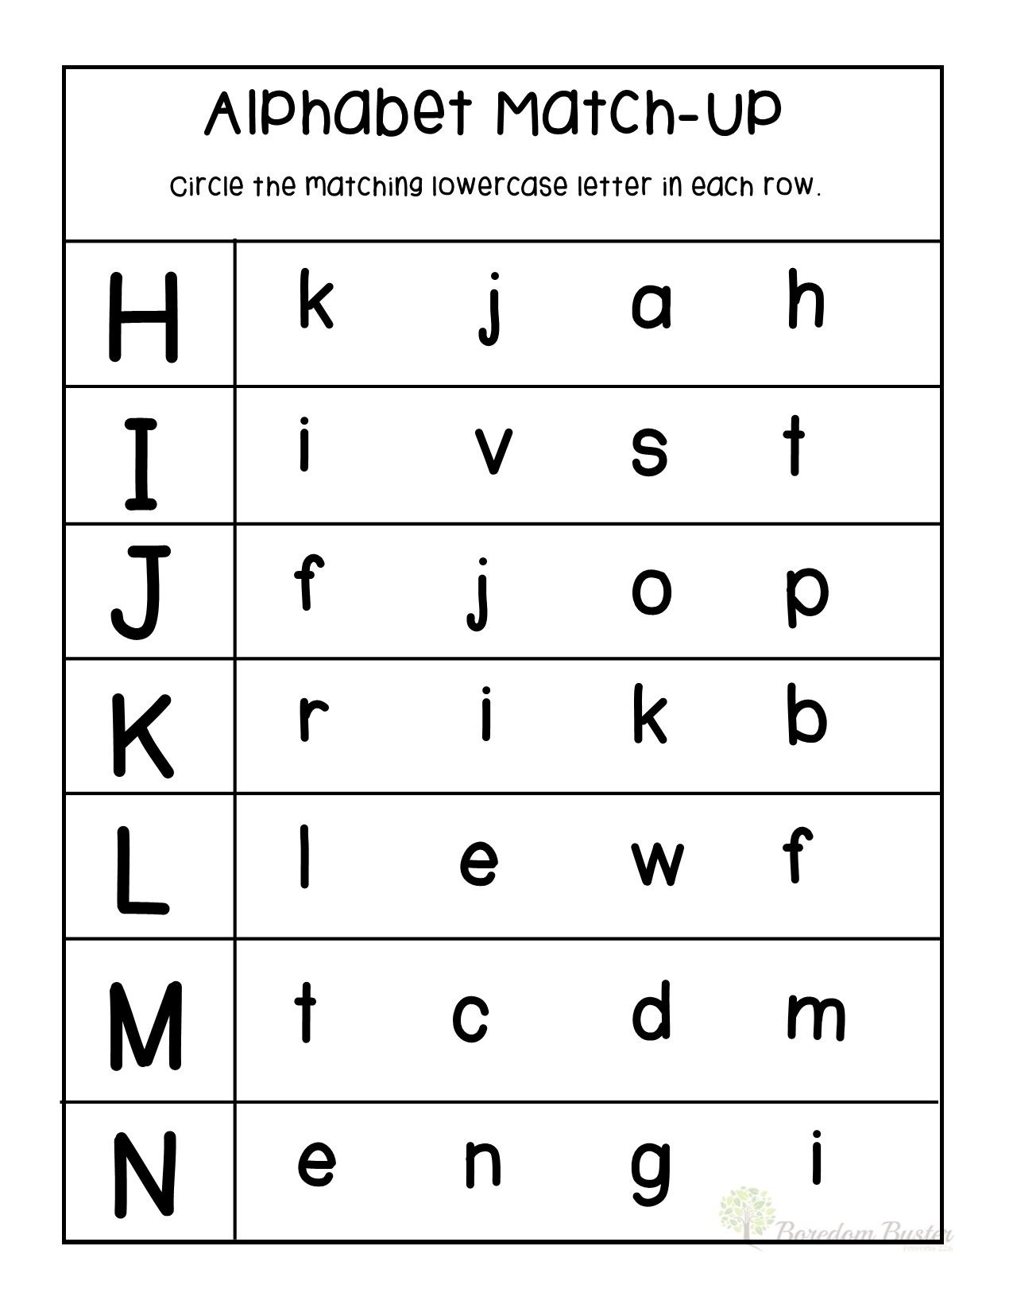

**Q N.2 Complete the missing letters.(7)**

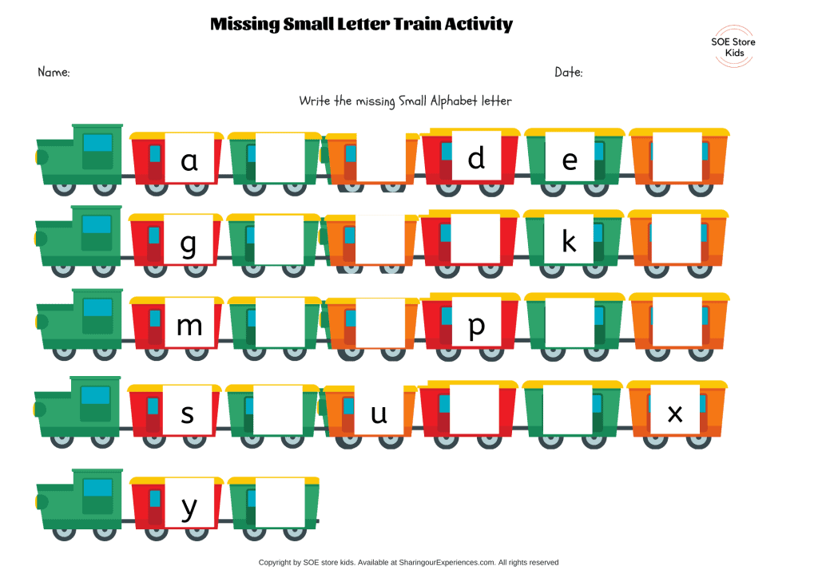

**Q N.3 Match the capital letters with small letters (8)**

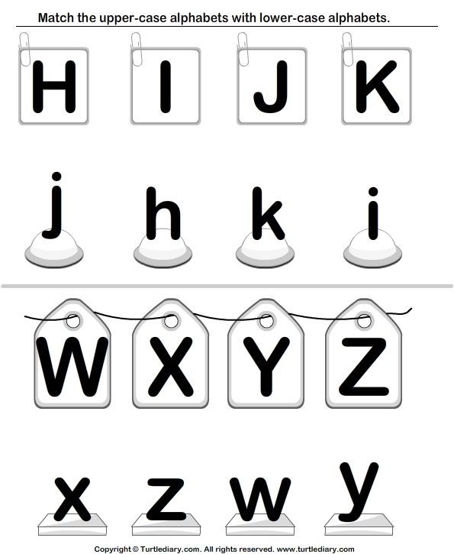

**Q N.4 Colour the correct alphabet (8)**

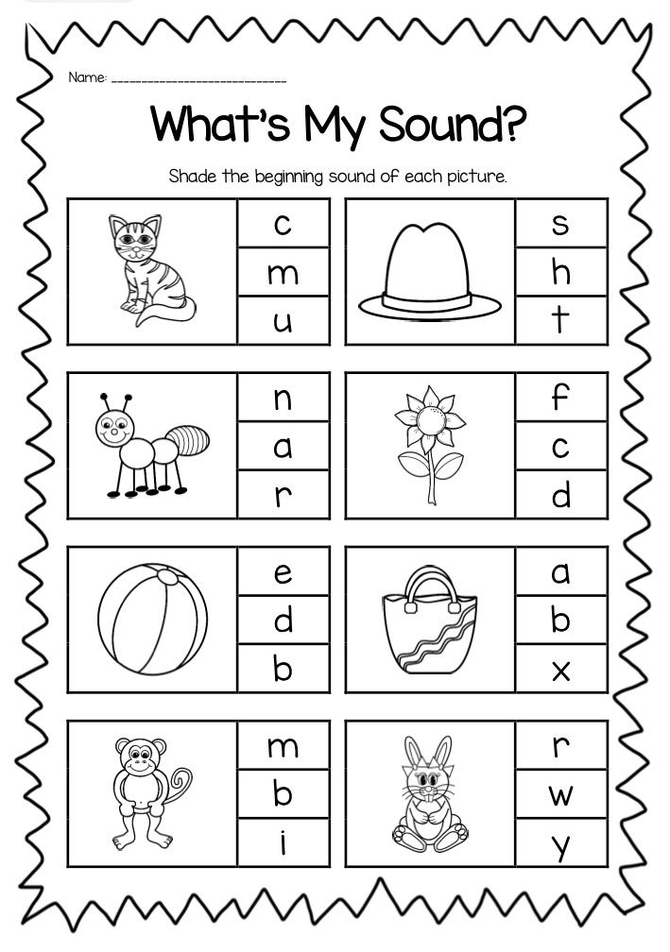

**Q N 5 Write down the missing capital letters. (13)** 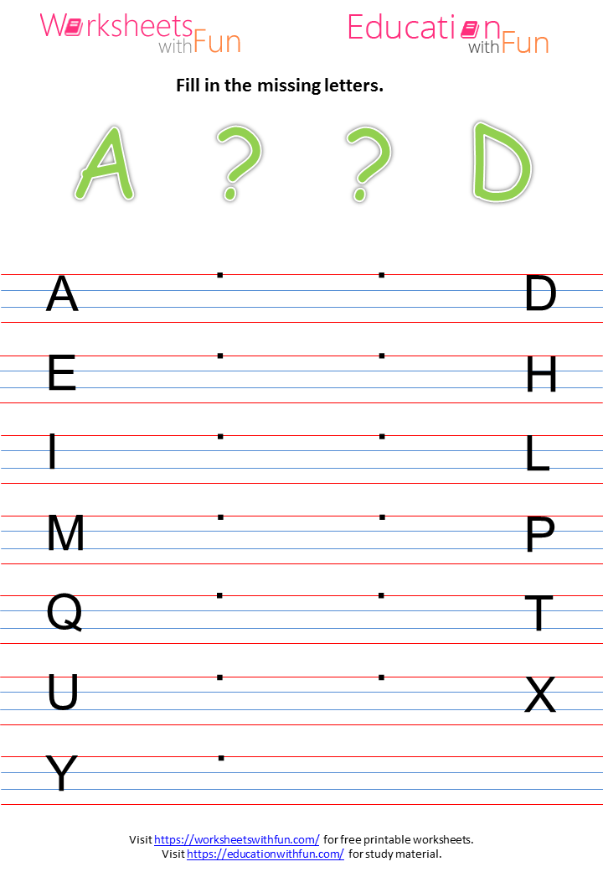

**Q N. 6 Match the same body parts (5)**

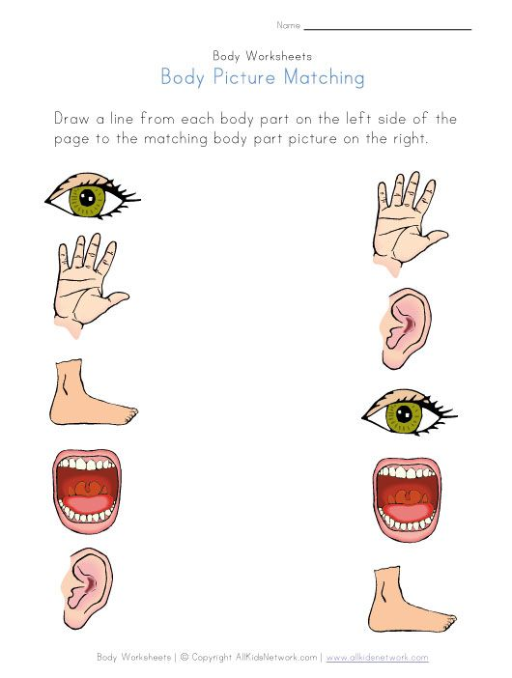

**Q N 7 Colour the picture.(2)**

